Co-Variance Matrix Calculation in Python

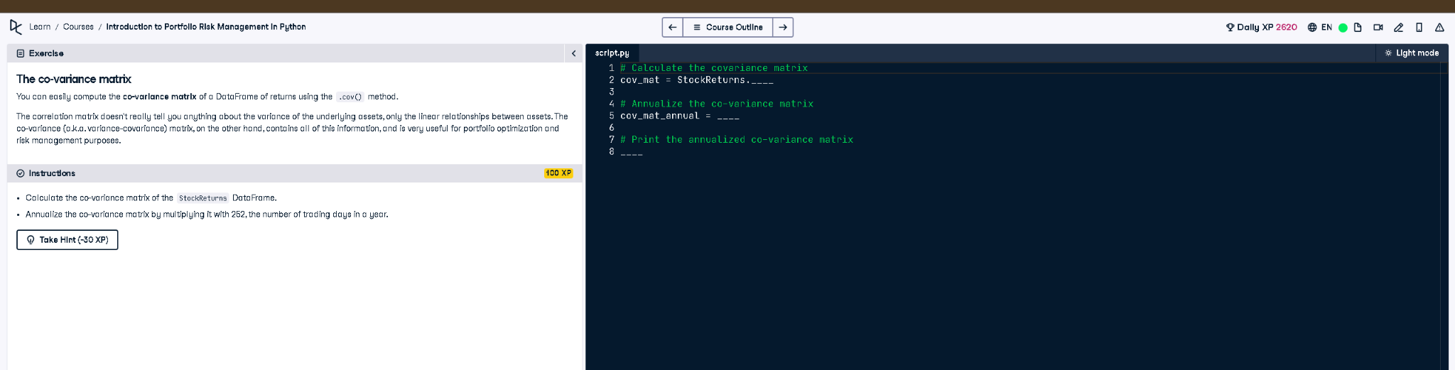

# Python Code

# Calculate the co-variance matrix  
cov_mat = StockReturns.cov()  
  
# Annualize the co-variance matrix  
cov_mat_annual = cov_mat * 252  
  
# Print the annualized co-variance matrix  
print(cov_mat_annual)

# Explanation (50 words)

This code calculates the covariance matrix of stock returns using the .cov() method. To annualize it, the matrix is multiplied by 252, the typical number of trading days in a year. This annualized covariance matrix is essential for risk analysis and portfolio optimization.